Have fun reading
with your child!
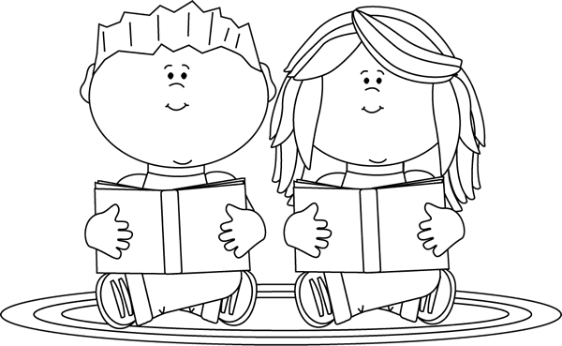
Please read this book to your child at least once and more often if possible. Choose those activities which fit this particular book, or think of your own way to enhance this particular book. You might want to try two or three of the suggested activities before, during, or after reading the story.
Illustration by Laura Strickland, MyCuteGraphics.com

Conversations About Books | Reading Strategies
By looking at the cover, what do you think this story might be about? | Predicting
Tell me what has happened so far in this book. | Summarizing, Comprehending
What do you think will happen next? | Predicting Outcomes
Stop before the ending and predict the ending. | Predicting or Forecasting Outcomes
Is this story Reality or Fantasy? How can you tell? | Drawing Conclusions
Draw or tell about your favorite character. | Identifying Character Traits
What is the setting for this story? | Identifying Story Elements
What were three things that happened in this story? | Retelling, Comprehending, Summarizing
Is there a special lesson to learn in this book? If so, what is it? Share what you learned. | Critical Thinking, Evaluating
Write your own story with your own characters, setting and ending using the same plot. | Identifying the Main Idea

Thank you for your support.
I hope you are enjoying this special experience with your child.

